|  |
| --- |
| **National University of Computer and Emerging Sciences** |
| In Lab Exercise  “Practice Questions on Triggers and SP” |
|  |
| Database Systems |
| Spring 2018 |

Department of Computer Science

FAST-NU, Lahore, Pakistan

# Exercise

Schema given in Order.sql file

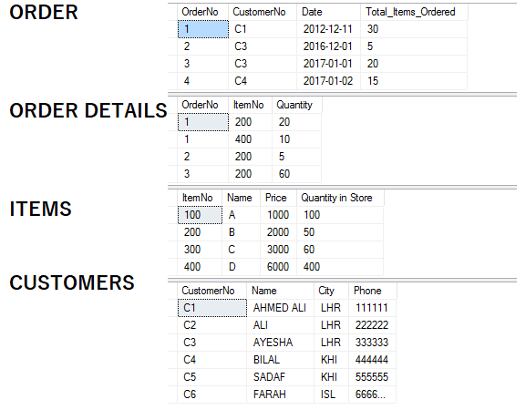

1. Create a trigger on Items that should not let you delete an item that has been ordered more than once.
2. Use procedures and triggers together to accomplish this task that you should not be able to increase items price but remember that you can decrease the price of item.
3. Create a procedure named as “CUSTOMER OF THE MONTH” based on their orders and the month given to it. (Hint : input of that procedure is a date)
4. Create a procedure that gives fifty percent 50% discount on the item which is minimum in sale.
5. Create a procedure that Accepts a date as input and returns
   1. Total sale of that month.(based on order Date)
   2. Item name with minimum sale
   3. Item name with maximum sale
   4. Customer of that month (based on max orders) (you may use above created procedure)

(Hint to accomplish that task try to create a separate procedure for each part a, b, c, d and use them to complete main task.)